Assignment04
- Suppose that the probability distribution of a random variable x can be describe by the formula
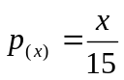
for each of the value x =1, 2, 3, 4, and 5. For example, then, P(x)=p(2)=2/15.

- Write out the probability distribution of x.

- Show that the probability distribution of x satisfies the properties of a discrete probability distribution.

- Calculate the mean of x.

- Calculate the variance, 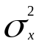, and the standard deviation, 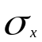.

- The United States Golf Association requires that the weight of a golf ball must not exceed 1.62 oz. The association periodically checks golf balls sold in the United States by sampling specific brands stocked by pro shops. Suppose that a manufacturer claims that no more than 1 percent of its brand of golf balls exceed 1.62 oz. in weight. Suppose that 24 of this manufacturer’s golf balls are randomly selected, and let x denote the number of the 24 randomly selected golf balls that exceed 1.62 oz. Figure 5.7 gives part of a MegaStat output of the binomial distribution with n=24, p=0.01 and q=0.99. (Note that, since P(X=x)=0.0000 for values of x from 6 to 24, we omit these probabilities). Use this output to

  - Find P(x=0), that is, find the probability that none of the randomly selected golf balls exceeds 1.62 oz. in weight.

  - Find the probability that at least one of the randomly selected golf balls exceeds 1.62 oz. in weight.

  - Find P(x3).

  - Find P(x2).

  - Suppose that 2 of the 24 randomly selected golf balls are found to exceed 1.62 oz. Using your result from part d, do you believe the claim that no more than 1 percent of this brand of golf balls exceed 1.62 oz. in weight?

. Figure 5.7
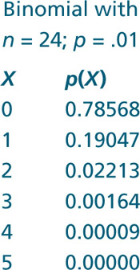
- For each of the following, calculate 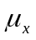, 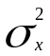, and 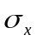by using the formulas given in this section. Then (1) interpret the meaning of and (2) find the probability that x falls in the interval [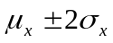].
  - The situation of Exercise 5.24(page225), where x= the number of the six customers who will make a purchase.

  - The situation of Exercise 5.25(page225), where x= the number of 15 sampled customers whose complaints were resolved to the customer’s satisfaction.

  - The situation of Exercise 5.26(page225), where x= the number of the 24 randomly selected golf balls that exceed 1.62 oz. in weight.

4. A local law enforcement agency claims that the number of times that a patrol car passes through
a particular neighborhood follows a Poisson process with a mean of three times per nightly shift. Let x denote the number of times that no patrol cars passes through the neighborhood during a nightly shift.

a. Calculate the probability that no patrol cars pass through the neighborhood during a nightly shift.

b. Suppose that during a randomly selected night shift no patrol cars pass through the neighborhood. Based on your answer in part a, do you believe the agency’s claim? Explain.

c. Assuming that nightly shifts are independent and assuming that the agency’s claim is correct, find the probability that exactly one patrol car will pass through the neighborhood on each of four consecutive nights.

